1. What does a high mutual information imply about the nucleotides at positions *i* and *j*?

High mutual information implies that knowing the nucleotide at position *i* tells you a lot about (or predicts with high probability) the nucleotide at position *j*. For example, if positions *i* and *j* have a high mutual information, then knowing that there is an A at position *i* means that there is a high probability that the nucleotide at position *j* is C (A and C arbitrarily picked for the purpose of this problem. They could by any combination of nucleotides.) Essentially the mutual information of two positions is a measure of how strongly nucleotides at those positions are conserved together in the dataset you are analyzing.

1. With the aid of a sketch (may be hand drawn or computer generated), summarize what the "top 20" and "top 50" results tell you about the secondary structure of transfer RNA.

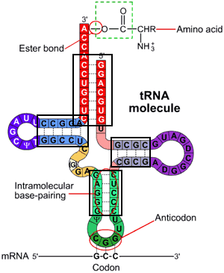The “top 20” and “top 50” results identify the 20 and 50 most prevalent pairings of nucleotide positions in the sample population. This implies that these are the 20 and 50 most significant interactions between nucleotide positions in the sequence, which can hint at the structure of the physical molecule. For example, in the figure below, one would expect the paired nucleotides that are boxed to be in the top 20 and top 50 since a given nucleotide on one side of the double stranded sections should correlate very strongly with its complementary nucleotide in the position directly across from it.